Experiment: Branching and Merging
Objective
Branching
A branch is a separate line of development in Git. It allows developers to work on new features or bug fixes independently without affecting the main branch.
Merging
Merging combines the changes made in one branch into another branch. After merging, the changes become part of the target branch.
P4Merge
P4Merge is a visual file comparison and merge tool. It displays the differences between two files or branches in a graphical interface, making it easier to identify and merge changes.
Branch Request
A branch request is the process of creating a new branch from the main branch to work on new features independently.
Merge Request
A merge request is used to merge the completed changes from one branch into another after review. In GitHub, this is called a Pull Request.
Steps
Step 1: Go to your Git folder
cd /c/Users/laksh/source/repos/CTS_DotNET5.0/"Deep Skilling"/Git

Step 2: Check current branch
git branch

Step 3: Create a new branch
git branch GitNewBranch

Step 4: List all local branches
git branch

Step 5: List local and remote branches
git branch -a

Step 6: Switch to the new branch
git checkout GitNewBranch

Step 7: Verify current branch
git branch

Step 8: Create a new file
echo "This file belongs to GitNewBranch" > branch.txt

Step 9: Verify
ls

Step 10: Check status
git status

Step 11: Add file
git add branch.txt
Step 12: Commit
git commit -m "Added branch.txt in GitNewBranch"

Step 13: Push the branch
git push -u origin GitNewBranch

Merging
Step 14: Switch back to main
git checkout main

Step 15: Compare the branches
git diff main GitNewBranch

Step 16: P4Merge (Lab Requirement)
Installing P4Merge
Commands:
Configure P4Merge
git config --global diff.tool p4merge
git config --global difftool.p4merge.path "C:/Program Files/Perforce/p4merge.exe"
git config --global difftool.prompt false
Verify Configuration
git config --global --list
Open P4Merge
git difftool main GitNewBranch
Step 17: Merge the branch
git checkout main
git merge GitNewBranch
Step 18: View the commit graph
git log --oneline --graph --decorate

Step 19: Delete the branch
git branch -d GitNewBranch

Step 20: Verify
git branch

Step 21: Push the merged changes
git push origin main

Step 22: Final status
git status
Outputs:
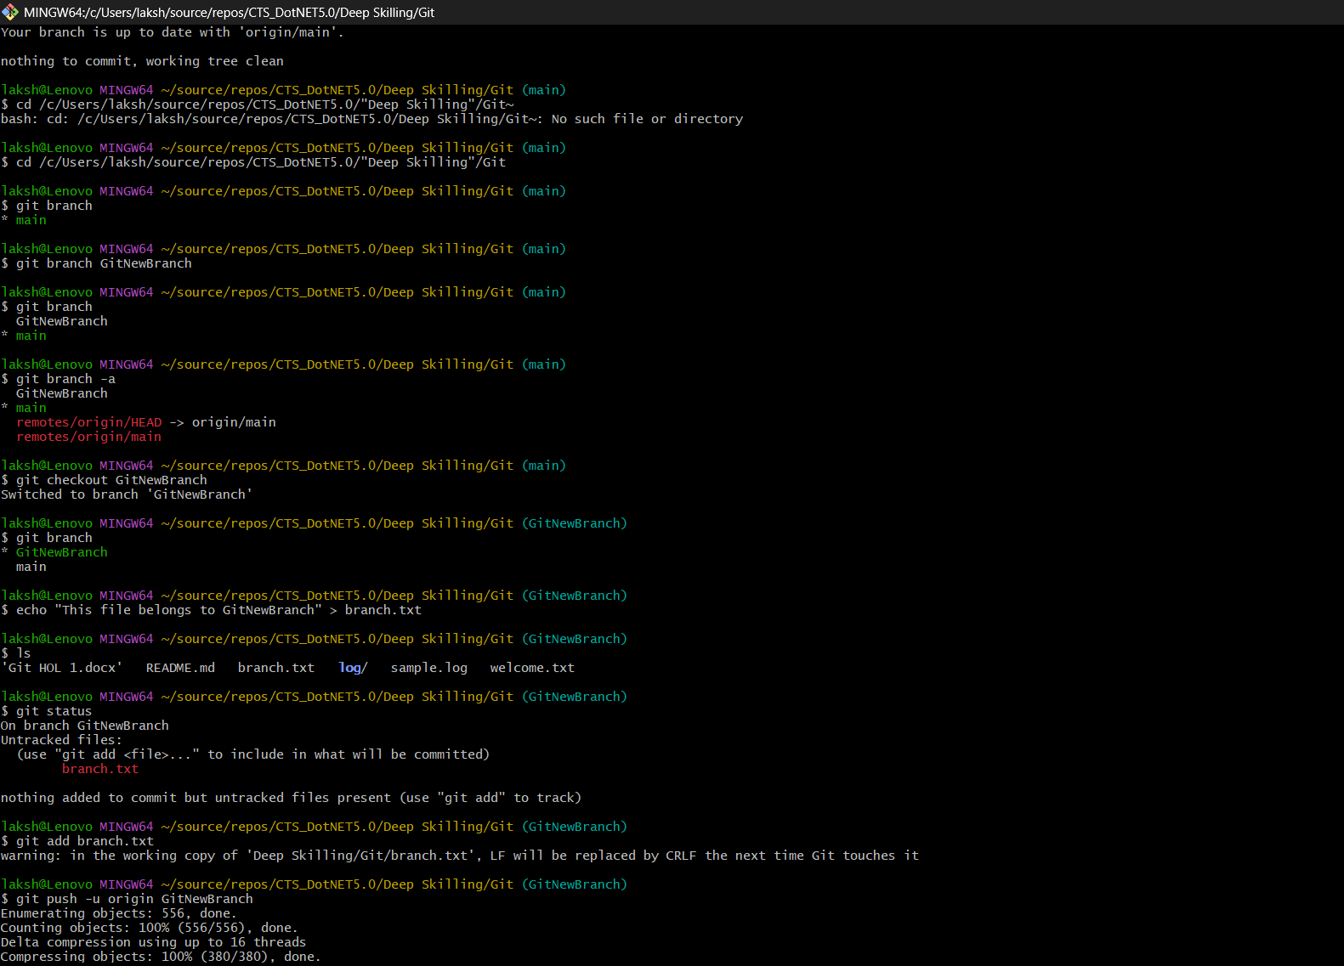
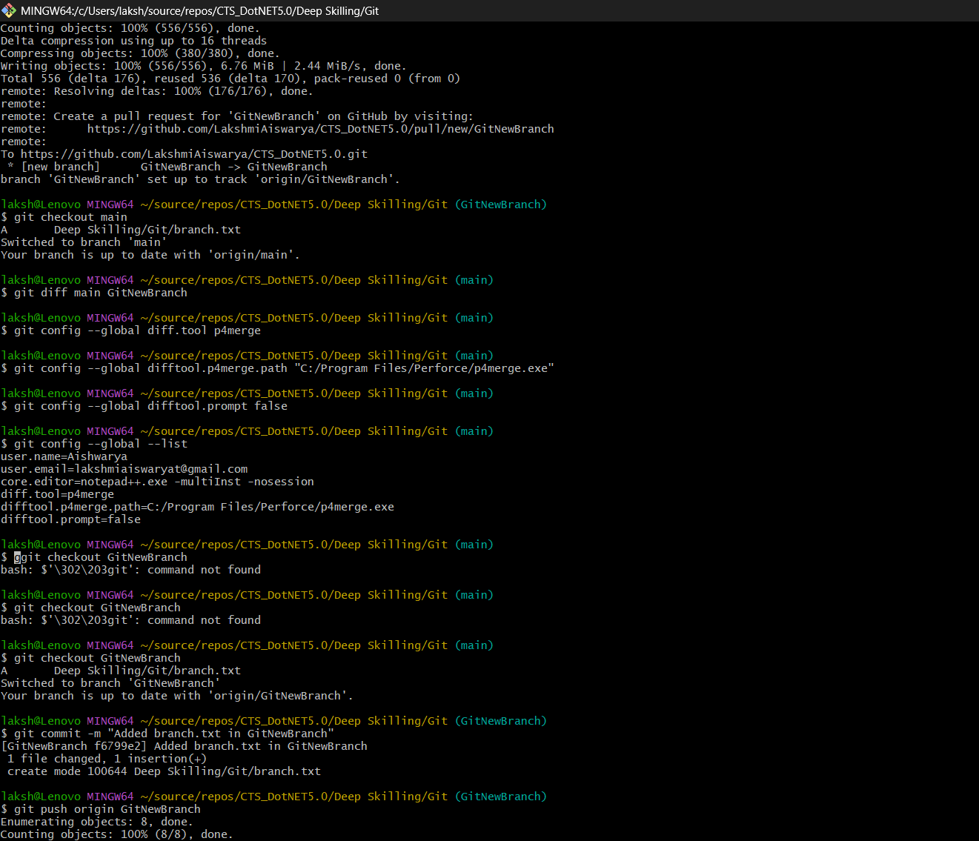

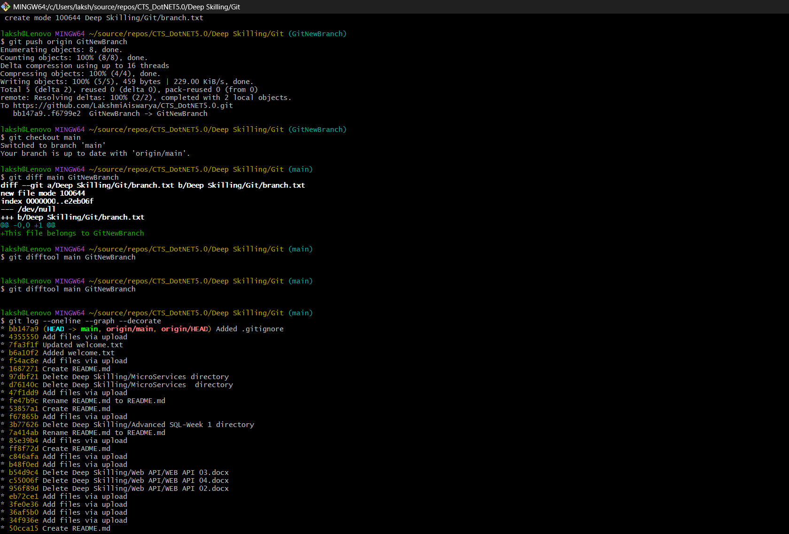
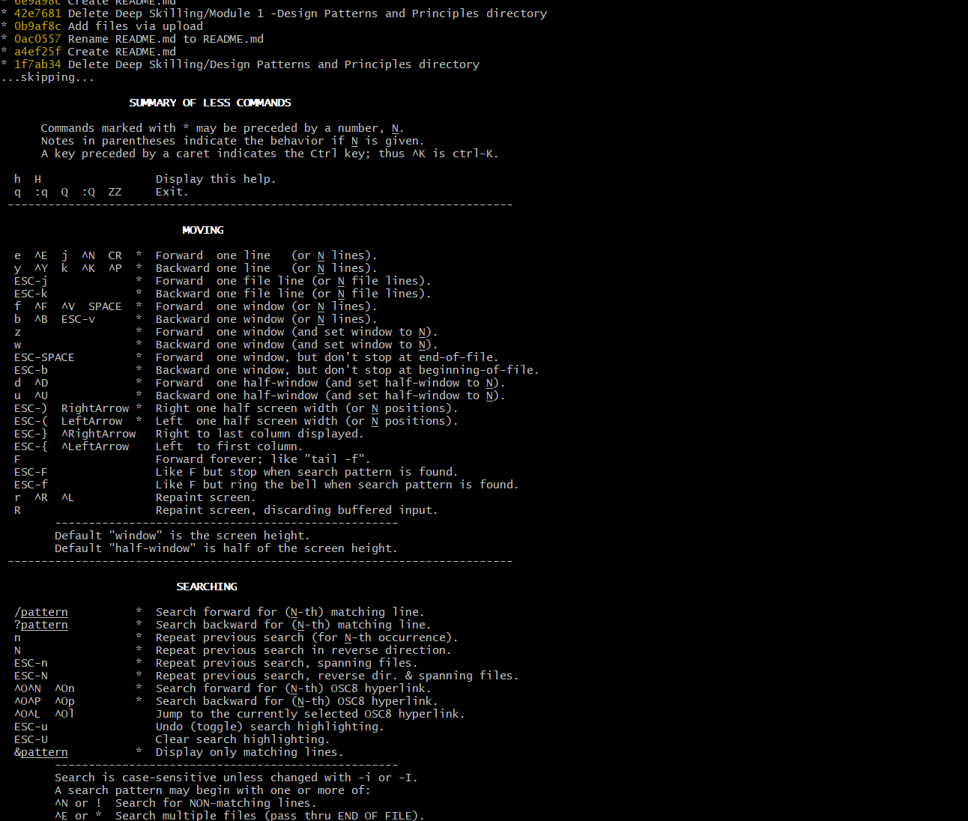
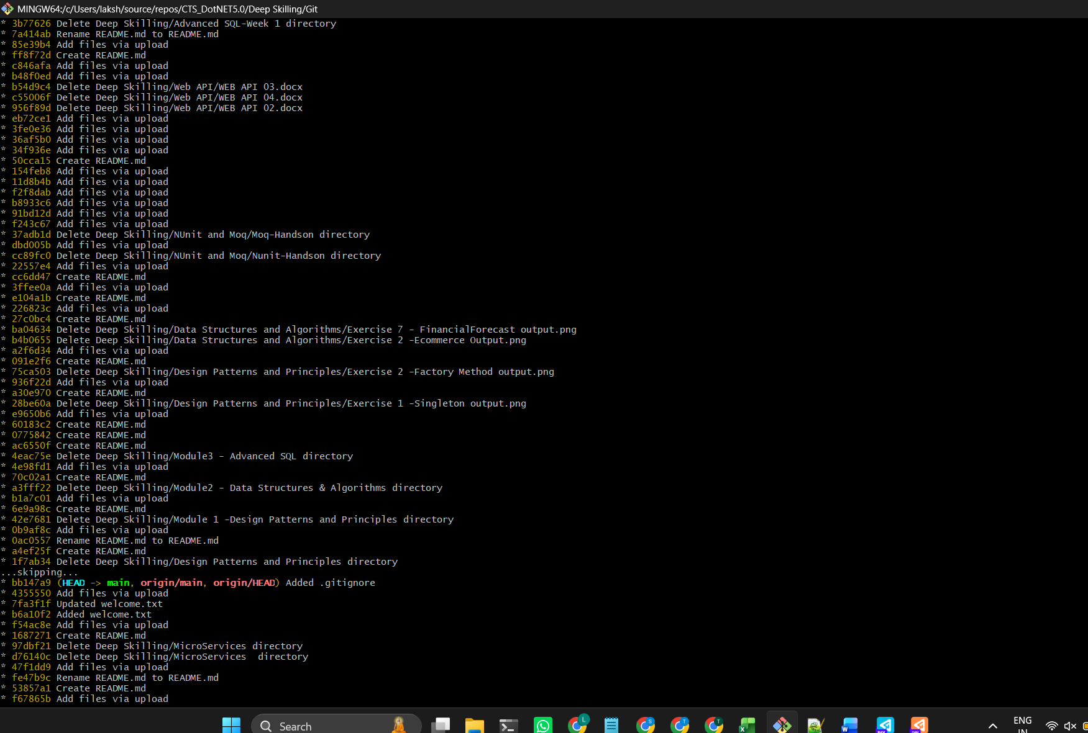
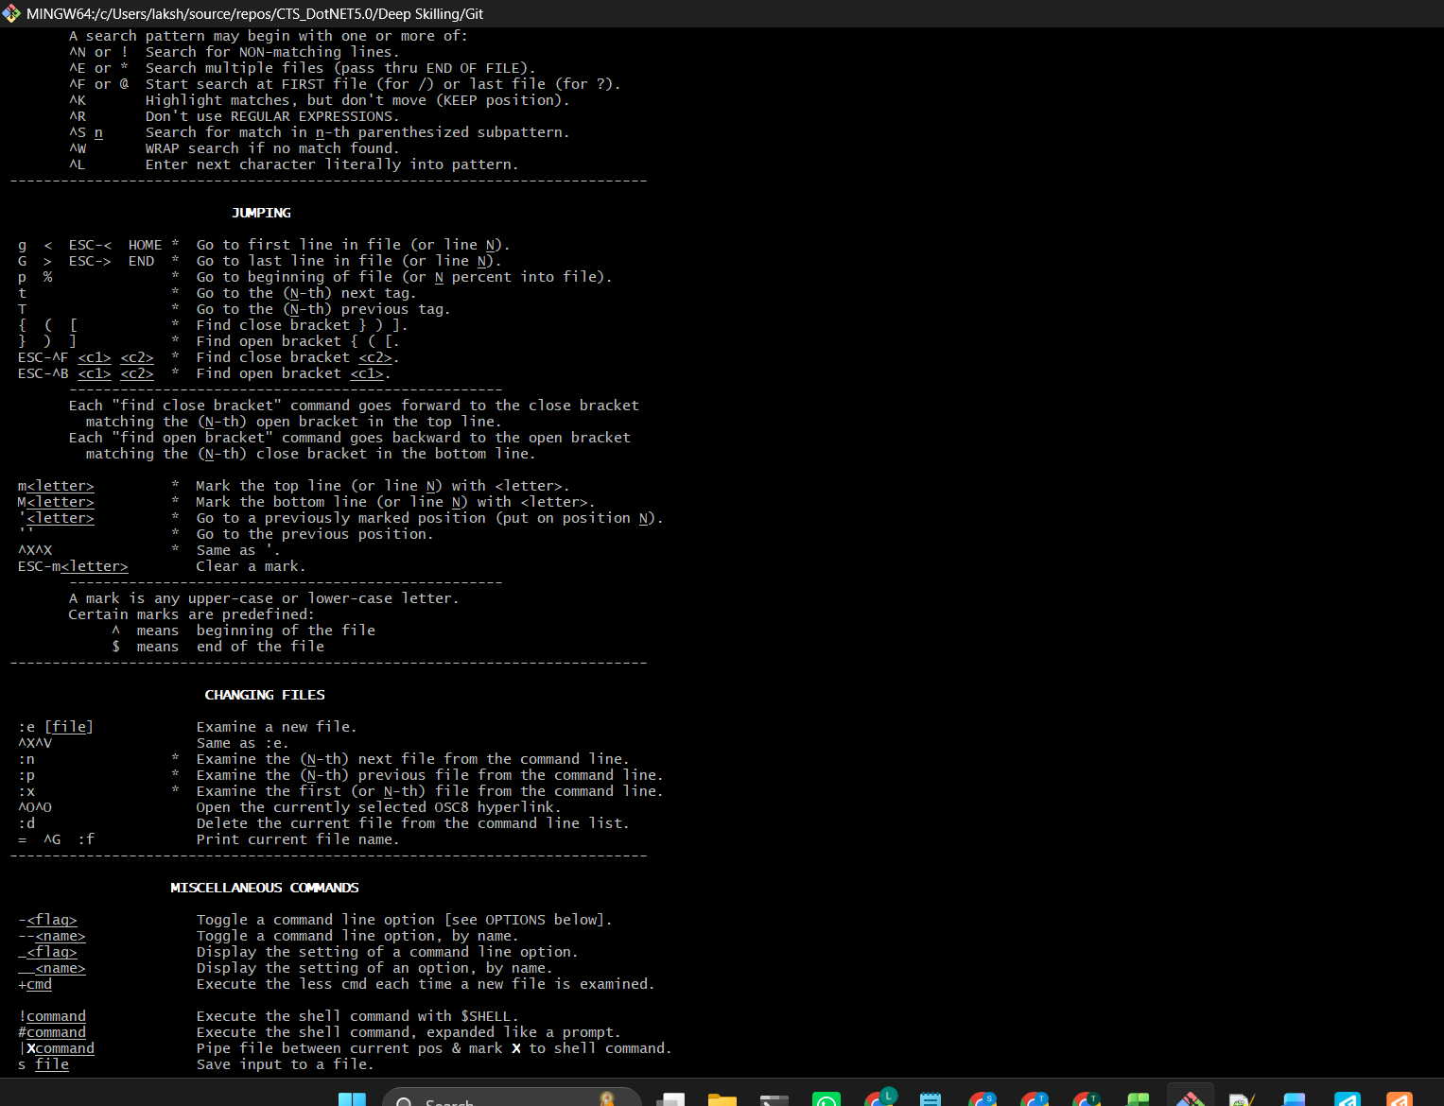

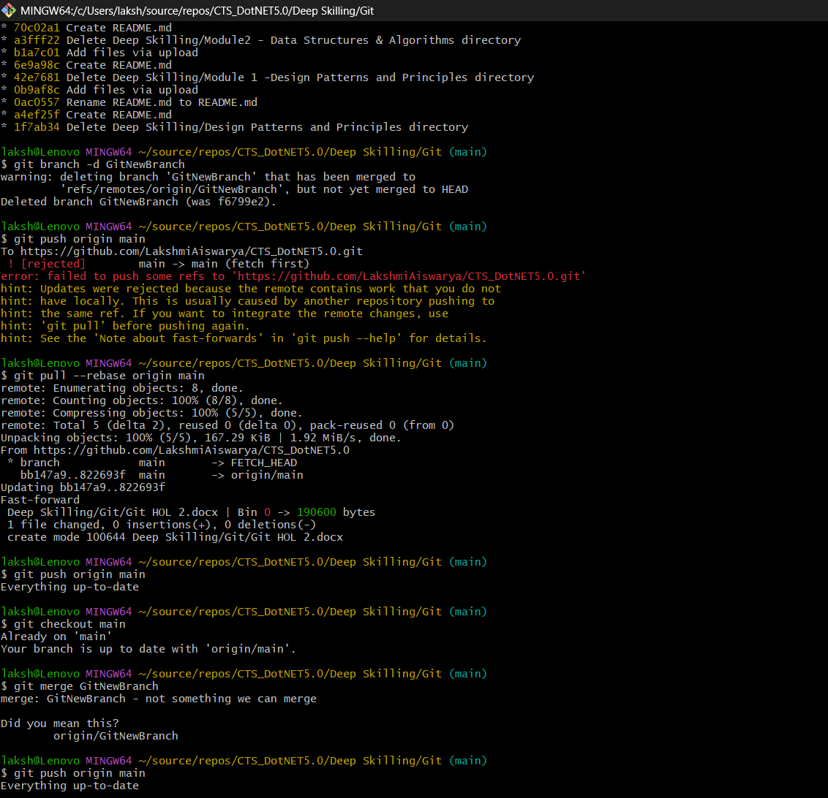

Result
A new branch GitNewBranch was created successfully. A new file was added and committed in the branch. The branch was merged into the main branch successfully, and the branch was deleted after merging.

